Basis Vectors

Given a coordinate, we can think of it as a scalar of the axes. For example, consider. Starting from the origin, we can arrive atby scaling the horizontal axisby 3, and the vertical axisby 1. Writing it as an equation, we get.

Here we see thatandare very important vectors, because our entire coordinate system is governed by assumptions around these vectors. We may think ofas travelling 1 unit towards the right, andas travelling 1 unit upwards. These 2 vectors are known as the “basis vectors” of our coordinate system.

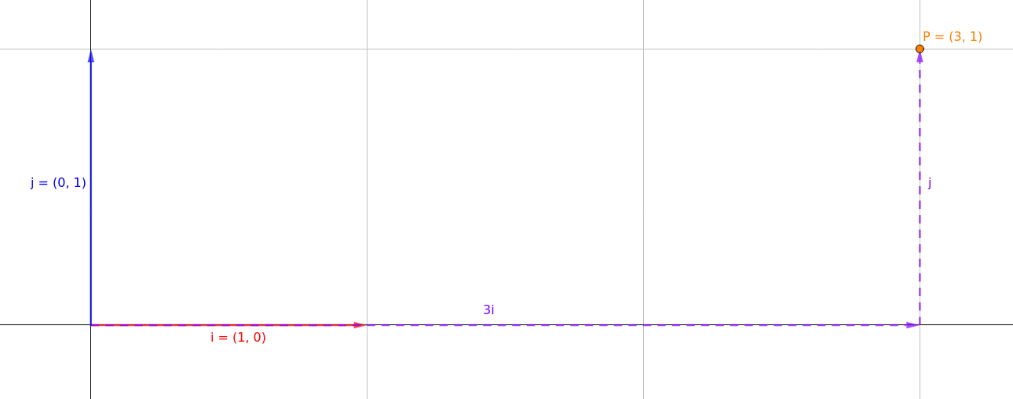

Shown in the figure above, we can arrive atby scaling our basis vectorsby 3, andby 1.

Let’s say would like a different set of vectors as our basis vectors, is it possible? Good news, we can! For example, we may decide to useand. This will mean that we have a new coordinate system, one where coordinates are represented as scalars ofand.

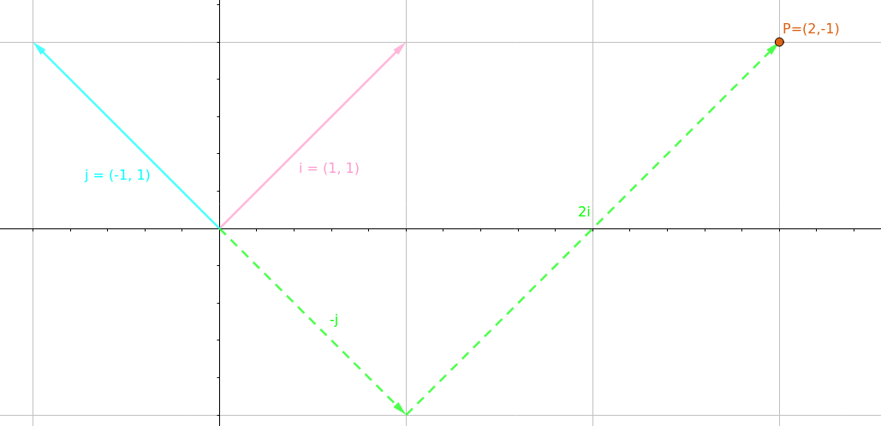
Withandas our basis vectors, ’s coordinates has changed. In our new system,’s coordinates is. This means that from the origin, we can arrive at ’s location in space by scaling our basis vectorsby 2, andby -1.

It is important to understandhasn’t actually moved at all. It is still in the same location it always was. The only thing that changed is how it is being represented due to the change in coordinate systems. We can prove this if we overlap the 2 figures.

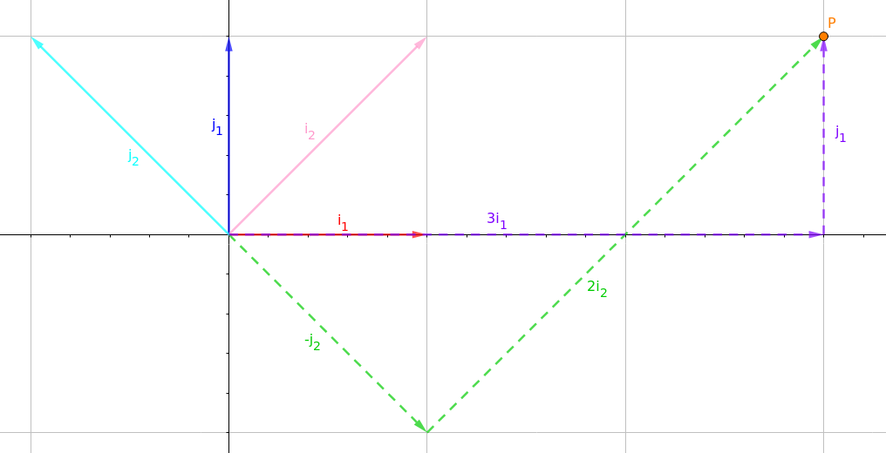
Looking back at the 2nd figure, you might be thinking this: “Woah, wait a minute… Scaling our “horizontal axis” by 2 and our “vertical axis” by -1 should give me, but if I write this down as an equation, I get. And as far as I can tell, andare pretty freaking different things!”

Well, yea… One point of confusion is how we represent the basis vectors versus how we represent.

Let’s give the 2 different coordinates systems a name. The original coordinates system usingandas the basis vectors will be called the “global” coordinates system. We will nameandasandrespectively.

The new coordinates system usingandwill be called the “local” coordinates system. We will nameandasandrespectively.

This is where things get a little messy.can be represented in “local” or “global” coordinates, butandare represented in “global” coordinates, even though they are the basis vectors of the “local” coordinates. This means that when we wrote, P is represented in terms of and. But andthemselves are represented in terms ofand. This is because there is no other way of showing the difference between the “global” and “local” coordinates. One coordinate system has to be relative to another, otherwise we would have no way of relating them to each other.

Matrix Transformation

Let’s consider the following transformation which can have different meanings, depending on the context.

Let’s take a look at some of the different meanings. As per above, we shall use the term “global” to represent the coordinates where our horizontal axis isand our vertical axis is. Coordinates represented by any other arbitrary axes shall be referred to as “local” coordinates.

Transforming A Global Point

Consider the pointlocated in global coordinates. In order to move this point, we can apply a transformation matrix onto it.

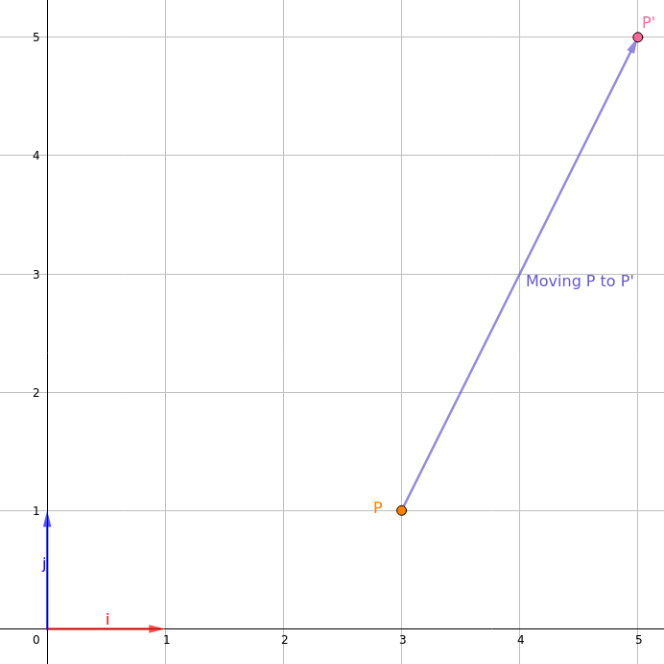
By applying the transformation matrix, we have movedfromin global coordinates toin global coordinates.

Here is another case, where we once again want to move the pointin global space. This time, we apply.

By applying the transformation matrix, we have movedfromin global space toin global space.

This is basically the same as the previous example, but I just want to point out that even when given an inverse matrix, we might still only be doing something as trivial as moving a point.

Change of Basis

Consider the pointlocated in the local coordinates of the axesand. What if we want to know the coordinates ofin global space? Since we know thatis the sum ofscaled by 3 andscaled by 1, we can derive that in global space, it is. Alternatively, we can write this using matrices.

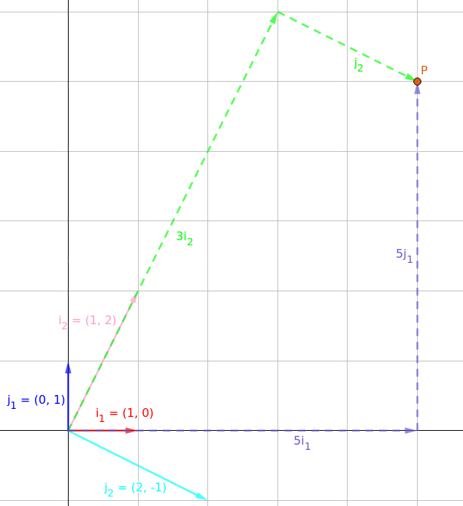
What if we are given the global coordinatesand want to find the local coordinates in terms of the axesand? Since, and we know that the inverse of a square matrix undoes its transformation, we get the equation.

Summary

In summary, when shown the transformation, there are 4 possible things that may be happening:

1.(point moves, no change of basis)

2.(point moves, no change of basis)

3.(point does not move, change of basis)

4.(point does not move, change of basis)

